Automated Student Attendance Monitoring and Analytics Systems For College

Vishal Gowda H School of Computer Science and
Engineering
Presidency University, Bangalore
Dr. Sreelatha P K
School of Computer Science and Engineering
Professor
Rakshitha D P
School of Computer Science and Engineering
Presidency University, Bangalore
Sai Siri Naidu O
School of Computer Science and Engineering
Presidency University, Bangalore

Abstract— Attendance tracking is one of the most important activities in educational institutions for assessing student attendance and engagement in class. However, current attendance recording techniques depend mainly on manual approaches such as using manual attendance forms and spreadsheets. Such approaches are not efficient and accurate, particularly when dealing with larger classes and lectures. This research presents an Automated Student Attendance Monitoring and Analytics System based on QR code technique. Here, the lecturer will create QR codes for each class, which will be scanned by the students through their cellphones to keep the record of attendance. In this way, the identity of the student who attended the class will be verified, and the attendance record will be kept in the database. Moreover, an advanced analytical tool will be used to identify the attendance pattern of the students.
Keywords—Automated Attendance System, QR Code Technology, Attendance Analytics, Educational Technology, Student Monitoring System

Introduction
The process of attendance registration is an essential aspect of any educational establishment because it shows the level of involvement of the students. In most universities and colleges, there is a rule of minimal attendance that the students must meet. Traditionally, attendance is monitored manually by instructors using attendance registers and sometimes spreadsheets on computers. Although this method has been used for decades, it suffers from various drawbacks.

Manually attending students is a time-consuming activity, which may also lead to errors due to miscounting or wrong entries. Additionally, this way of attendance monitoring cannot be effective in managing large audiences. Thanks to the rapid development of technologies, modern educational institutions use computerized systems to manage administrative processes.

An alternative to the mentioned manual technique is the implementation of some automated attendance systems based on RFID technology, biometric scans, or face recognition. However, all those options require the installation of costly equipment and maintenance of a complex IT infrastructure.

QR-code is another way of attendance monitoring; however, QR-code scanners are available in many smartphones, allowing saving costs associated with purchasing additional equipment. This research paper considers the introduction of the automated attendance monitoring system based on QR code technology.

Literature Review
A number of research works have been conducted on automatic attendance monitoring systems using various technological approaches, including RFID, biometric systems, QR codes, and face recognition techniques [2], [4]. Traditional approaches using RFID-based systems allow identification of students using ID card scanning, which is fast but expensive since dedicated hardware like RFID scanners is required [2].
Biometrics-based systems like fingerprint and iris recognition provide highly accurate results. They are very reliable for attendance tracking. However, biometrics-based solutions require special hardware and suffer from long response times due to their sequential operation [4].
The development of computer vision algorithms allowed face recognition-based solutions to become more popular. One of the early studies proposed face recognition-based solutions was done by Lee et al. [5]. The researchers suggested real-time face recognition solutions for attendance purposes. In recent studies, deep learning approaches are employed to improve accuracy and robustness of the solution. Kumar et al. [6] used deep learning to develop a real-time face recognition solution, while Nair et al. [7] proposed a CNN-based method to enhance face recognition performance. Sharma et al. [9] used face recognition algorithms to build a real-time attendance system.
There have been recent efforts aimed at increasing the efficiency and intelligence of face recognition systems. Reddy et al. [8] developed an attendance system that employs AI, thereby increasing the accuracy and intelligence of the system. Further, Gupta et al. [10] have developed an attendance system that uses speech-enabled machine learning combined with face recognition to increase interaction and intelligence of the system. Also, the works done by Ali et al. [11] used Haar Cascade classifier technique for detecting faces.
At the same time, studies aimed at developing cost-effective attendance systems using QR codes were conducted as well. They include works by Singh and Sharma [1] and Patel [3]. The proposed methods utilize creation of a unique QR code for each class that can be quickly and easily scanned using a mobile phone [1], [3].
Conclusively, it is clear from the research performed above that even though RFID and biometric approaches ensure reliability, they are costly and hardware-based, which makes them less advantageous than face detection systems and QR code systems.
Method | Advantages | Limitations
RFID | Fast | Expensive hardware
Biometric | Accurate | Time-consuming
Face Recognition | Contactless | Lighting issues
QR Code | Low cost | Requires smartphone

Proposed System
This system uses Face Recognition and QR code technology to monitor attendance. The system is made up of several different modules that will help in collecting attendance information about students.

3.1 System Overview
Using the system, professors can create a unique QR code along with face recognition for each class meeting. The student will be required to use his or her cell phone to click picture of face and scan the QR code in order to take attendance. The attendance information will then be sent to the server and stored in the database.

Another module of the system will analyze the attendance data collected to provide attendance statistics.

3.2 System Modules

Student Registration Module
This module enrolls students in the system. Students are provided with an individual student ID together with their personal information, which include the following:
- Name
- Department
- Semester
- Course information
The student data is stored in the database.

Faculty Login Module
The faculty uses secure user credentials to log into the system. After logging in, the faculty are able to:
- Generate QR codes for attendance
- View attendance reports
- Monitor student attendance statistics

Face Recognition Module
This module uses camera to recognize students face and validate it before generating QR code for marking attendance.

QR Code Generation Module
The system creates an encoded QR code that has information like:
- Course ID
- Lecture ID
- Date and time
- Faculty ID
The QR code is displayed on the classroom screen for students to scan.

QR Code Scanning Module
QR code scanning by the students is done through the use of their mobile application. Scanning of the QR code allows the encoded information to be sent to the server, together with the student ID number for validation of attendance.

Attendance Database Module
The attendance data will be stored in the database which consists of following fields:
- Student ID
- Course ID
- Date
- Time
- Attendance Status
This database enables efficient storage and retrieval of attendance records.

Analytics Module
The analytics module is used for analysis of attendance data to create different statistics such as:
- Student attendance percentage
- Subject-wise attendance analysis
- Monthly attendance trends
- Identification of students with low attendance
These analytics process help faculty and administrators to monitor student participation efficiently.

System Architecture
The proposed system follows a client-server architecture.

Components of the System
User Interface
Offers access to students and teachers via web-based or mobile-based interfaces.
Application Server
Holds and manages attendance records, generates QR codes, and handles authentication.
Database Server
Houses data of students and attendance records.
Analytics Engine
Analyzes attendance records and creates reports.
Interaction among all these parts makes attendance management efficient and safe.

Implementation
The system can be implemented using commonly available web development technologies.
Component | Technology
Frontend | HTML, CSS, JavaScript
Backend | Python flask
Database | SQLite
QR Code Library | QRCode Library

Upon execution, face recognition and a unique QR code is generated for every class period to avoid any form of duplication. The validity of the QR code is also limited in order to ensure that only current students in class register attendance.
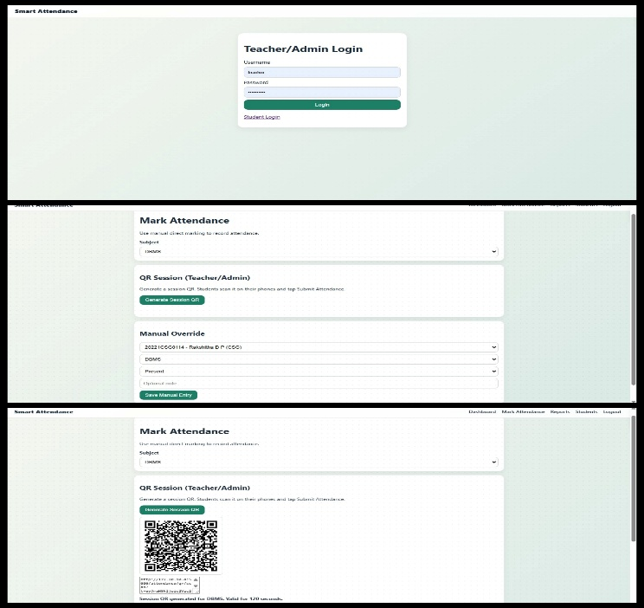
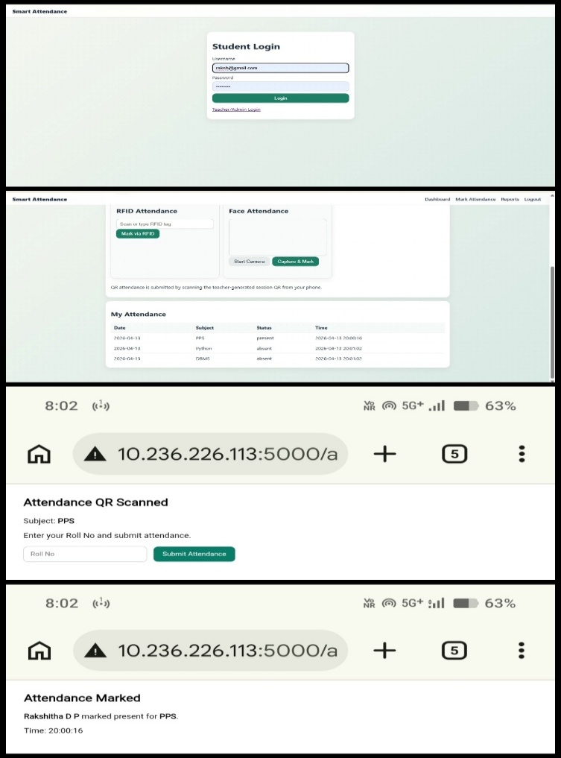

.
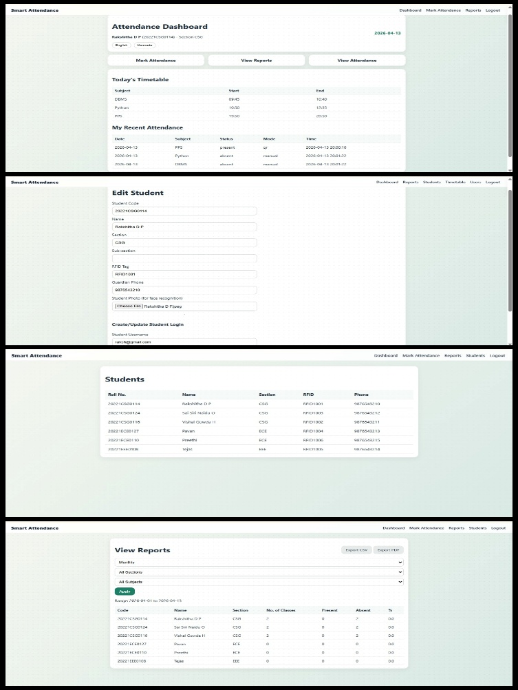

Results and Discussion
The proposed QR Code Attendance System was implemented in a virtual classroom setup. The results indicate that this system greatly decreases the time required to take attendance.

Taking the attendance of 60 individuals manually will consume about 5 to 7 minutes. The QR code together with the face recognition technology will enable one to take attendance in less than a minute.

In addition to this, the analytics tool will be able to provide the teacher with complete attendance report cards that will help them evaluate their students’ performance.

Apart from this, this system is even able to minimize errors that are associated with manual attendance taking. This is possible by both Teachers and Students through accessing various access controls.

Advantages of the Proposed System
The proposed system offers several advantages:
- Reduces time required for attendance recording
- Eliminates manual paperwork
- Provides accurate and reliable attendance data
- Generates detailed attendance analytics
- Easy to implement and maintain
- Low infrastructure cost

Future Work
Future improvements can enhance the security and functionality of the system. Possible enhancements include:
- Location-based verification using GPS module
- Integration with learning management systems (LMS)
- Machine learning algorithms for predicting student attendance trends
These improvements can further increase the reliability and usefulness of automated attendance systems.
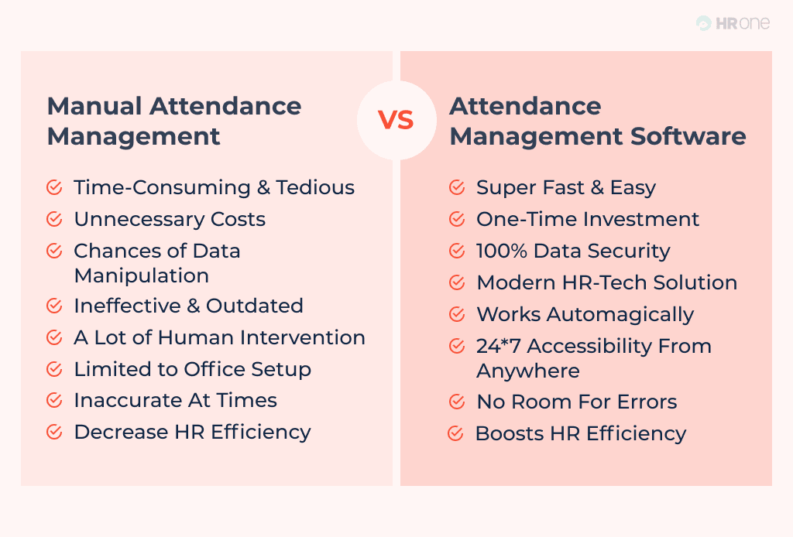

Conclusion
This study proposes an Automated Student Attendance Monitoring and Analysis System using features like facial recognition and QR code technologies for better accuracy. In addition to automating the attendance system, this provides valuable insight into the trends associated with student attendance.

The introduction of a QR code-based system helps in minimizing the efforts that would otherwise be required by institutions if manual systems were to be used. Thus, this system helps in solving attendance issues faced by institutions.

References
[1] K. Singh and P. Sharma, “Smart Attendance System using QR Code,” International Journal of Computer Applications, vol. 182, no. 12, pp. 15–20, 2021.
[2] S. Kumar, “Automated Attendance Monitoring System,” IEEE International Conference on Smart Education Systems, 2020.
[3] A. Patel, “QR Code Based Attendance System for Educational Institutions,” International Journal of Engineering Research and Technology, vol. 8, no. 6, pp. 120–125, 2019.
[4] R. Gupta and M. Sharma, “Digital Attendance Monitoring System,” IEEE Conference on Emerging Technologies, 2022.

[5] J. Lee, H. Kim, and S. Park, “Real-Time Face Recognition Attendance Monitoring System,” in Proc. Int. Conf. on Advanced Computing and Communication Systems, 2017.

[6] R. Kumar, A. Singh, and P. Verma, “Real-Time Attendance System Using Deep Learning Face Recognition,” in Proc. IEEE Int. Conf. on Artificial Intelligence and Machine Learning, 2020.

[7] S. Nair, V. Menon, and R. Pillai, “CNN-Based Attendance Management System Using Face Recognition,” in Proc. Int. Conf. on Intelligent Systems and Applications, 2023.

[8] K. Reddy, M. Rao, and S. Kumar, “AI-Based Real-Time Student Attendance System,” in Proc. IEEE Int. Conf. on Smart Technologies and Systems, 2024.

[9] P. Sharma, D. Gupta, and A. Mishra, “Real-Time Smart Attendance System Using Face Recognition Techniques,” in Proc. Int. Conf. on Computer Vision and Image Processing, 2021.

[10] A. Gupta, S. Jain, and R. Mehta, “Speech-Enabled Machine Learning Attendance System with Face Recognition,” in Proc. IEEE Int. Conf. on Emerging Technologies in Computing, 2023.

[11] M. Ali, S. Khan, and F. Ahmed, “Face Recognition-Based Attendance System Using Haar Cascade,” in Proc. Int. Conf. on Image Processing and Computer Vision, 2023.

